St. Francis Institute of Technology, Mumbai-400 103

**Department Of Information Technology**

A.Y. 2024-2025

Class: TE-ITA/B, Semester: V

Subject: **DevOps Lab**

**Experiment – 8: To setup and run Selenium tests in Jenkins using Maven.**

1. **Aim:** To setup and run Selenium tests in Jenkins using Maven
2. **Objectives:** Aim of this experiment is that, the students will learn:

* Selenium and how to automate your test cases for testing web elements
* Introduction to X-Path, TestNG and integrate Selenium with Jenkins and Maven.

1. **Outcomes:** After study of this experiment, the students will learn following:

* Introduction to Selenium
* Installing Selenium
* Creating Test Cases in Selenium WebDriver
* Run Selenium Tests in Jenkins Using Maven

1. **Prerequisite:** Knowledge of Software Engineering concept of testing and test cases.
2. **Requirements:** Jenkins,JDK, Eclipse IDE, Firefox browser,Personal Computer, Windows operating system, Internet Connection, Microsoft Word.
3. **Pre-Experiment Exercise:**

**Brief Theory:** Refer shared material

1. **Laboratory Exercise**
   * + 1. **Procedure:**

**a. Answer the following:**

* Explain Selenium suite?

The **Selenium suite** is a set of open-source tools for automating web application testing across various browsers and platforms. It consists of four main components:

1. **Selenium IDE**: A user-friendly record-and-playback tool for creating test scripts quickly, suitable for beginners.
2. **Selenium WebDriver**: A more advanced tool for programmatically controlling web browsers, allowing for robust and flexible test automation.
3. **Selenium Grid**: A tool that enables running tests in parallel across multiple machines and browsers, enhancing efficiency and reducing testing time.
4. **Selenium RC (Remote Control)**: The original tool for browser automation, now deprecated in favor of WebDriver.

Key Benefits:

* **Cross-browser support**: Works with major browsers.
* **Language flexibility**: Supports multiple programming languages.
* **Open-source**: Free to use with community support.

### Use Cases:

* Functional and regression testing
* Cross-browser testing
* Continuous Integration (CI) automation
* What are the limitations of Selenium IDE?

1. Limited Functionality: Lacks advanced features for complex interactions (e.g., drag-and-drop).
2. No Parallel Execution: Cannot run tests simultaneously, leading to longer execution times.
3. Browser Compatibility: Primarily available for Chrome and Firefox, limiting its use on other browsers.
4. Dependency on JavaScript: Relies on JavaScript, which may not handle all interactions effectively.
5. Fragile Tests: Recorded tests can break easily with UI changes, requiring frequent updates.
6. No Conditional Logic: Lacks support for complex test logic like loops or if-else statements.
7. Integration Limitations: Limited integration options with other testing frameworks and tools.
8. No Back-End Testing: Focuses solely on front-end testing, not suitable for server-side or API testing.

**b**. **Execute following (Refer the shared material) and attach screenshots:**

* Create and run a test case on Chrome/Firefox browser with selenium IDE addon
* Create a Maven Project in Jenkins and run selenium tests using selenium Grid

1. **Post-Experiments Exercise**
2. **Extended Theory:**

Nil

1. **Questions:**

* What are Locators? Explain its types.
* What is the benefit of using Selenium Grid with Jenkins?

1. **Conclusion:**

* Write what was performed in the experiment.
* Write the significance of the topic studied in the experiment.

1. **References:**

<https://jenkins.io/doc/>

<https://www.slideshare.net/abediaz/introduction-to-jenkins>

<https://q-automations.com/2019/09/26/selenium-grid-with-jenkins/>

* Create and run a test case on Chrome/Firefox browser with selenium IDE addon

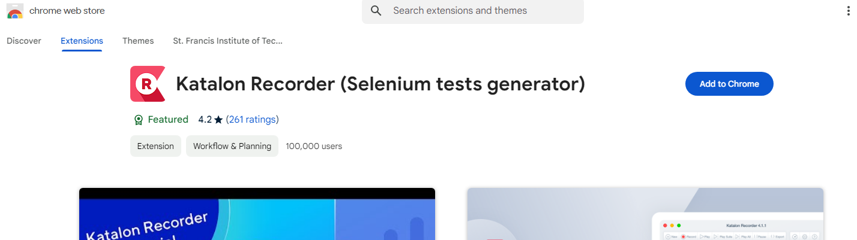

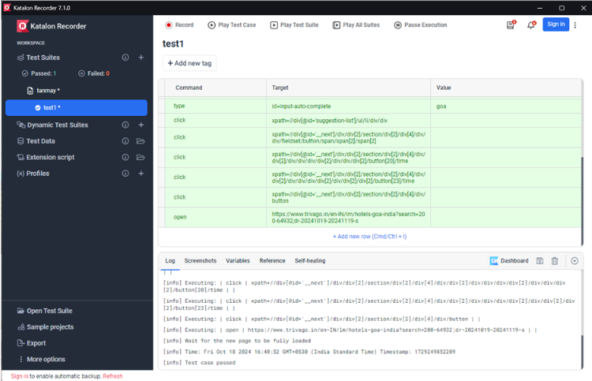

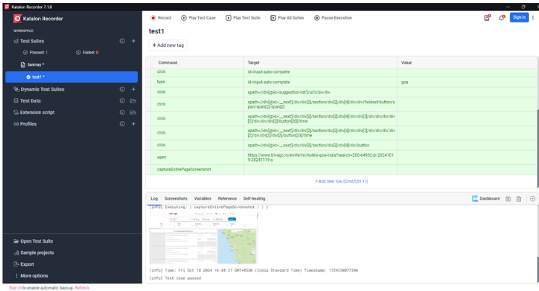

* Create a Maven Project in Jenkins and run selenium tests using selenium Grid

~check for selenium plugins to install

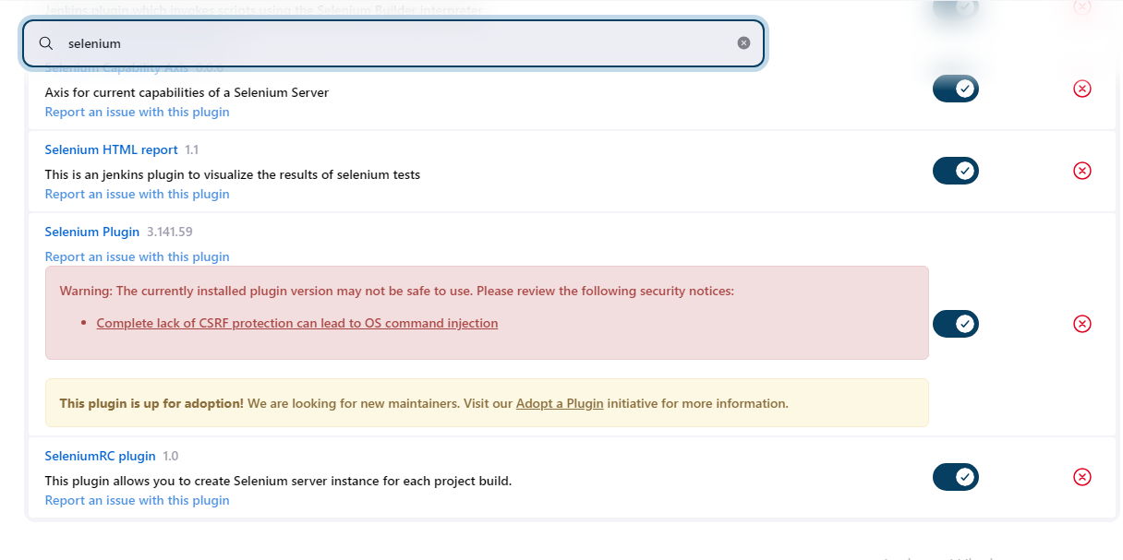

~check for hub management configuration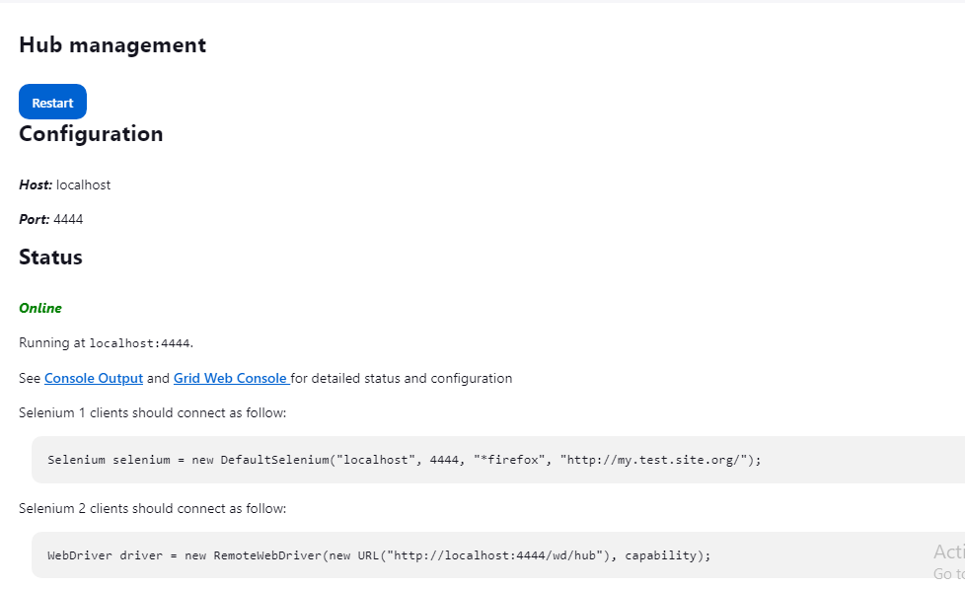

~creating a new configuration in selenium grid

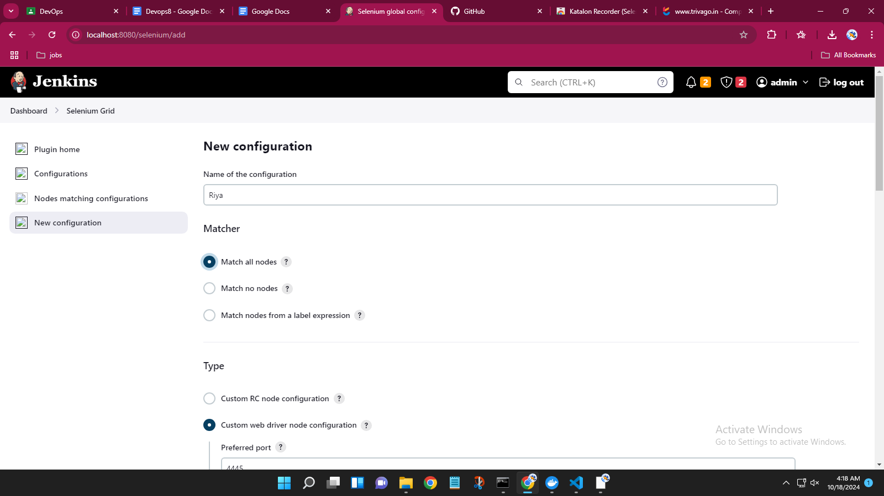

Forking repository to add to selenium grid

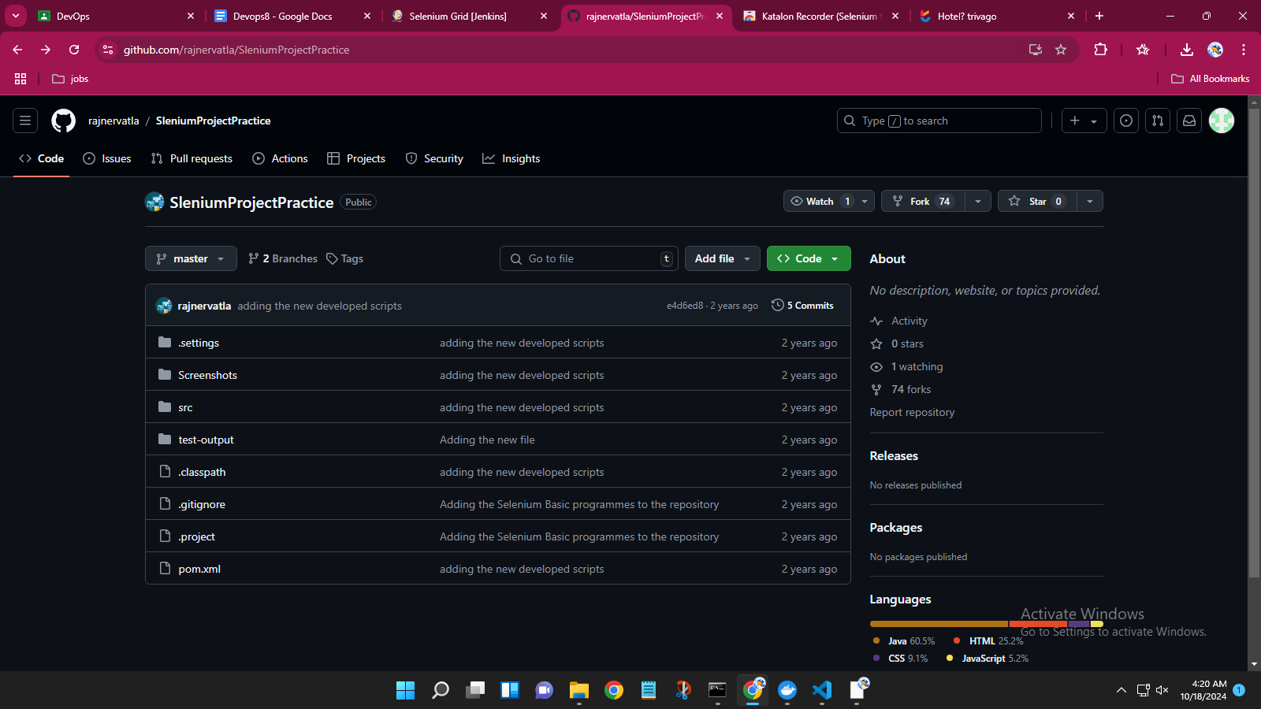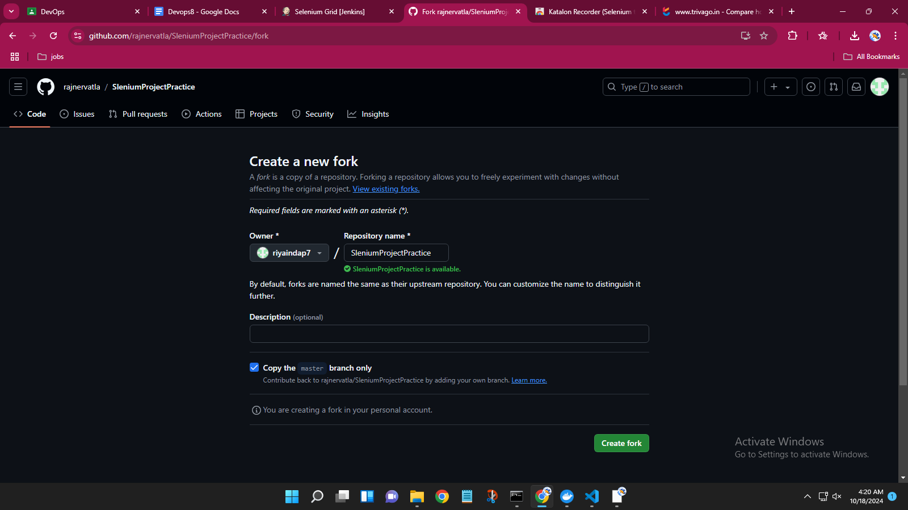

~creatina a new view item

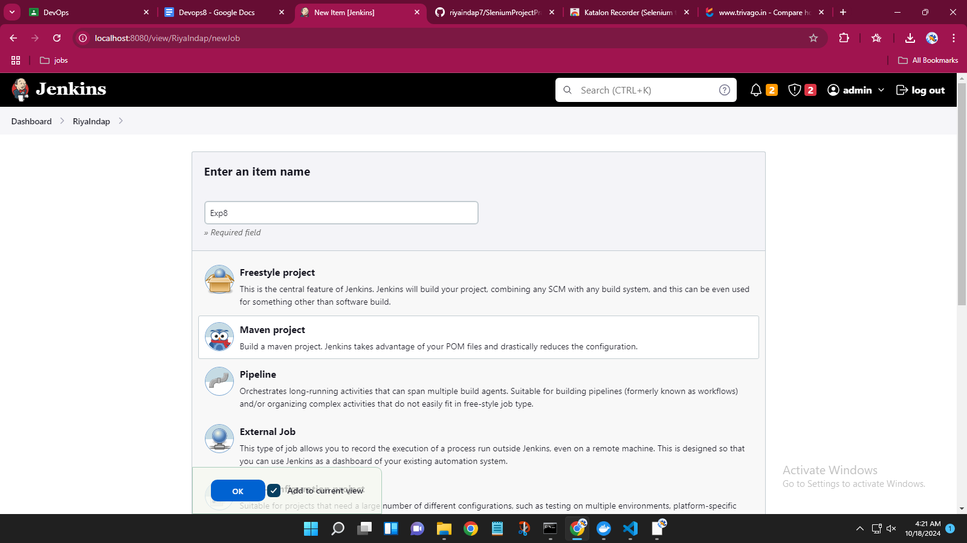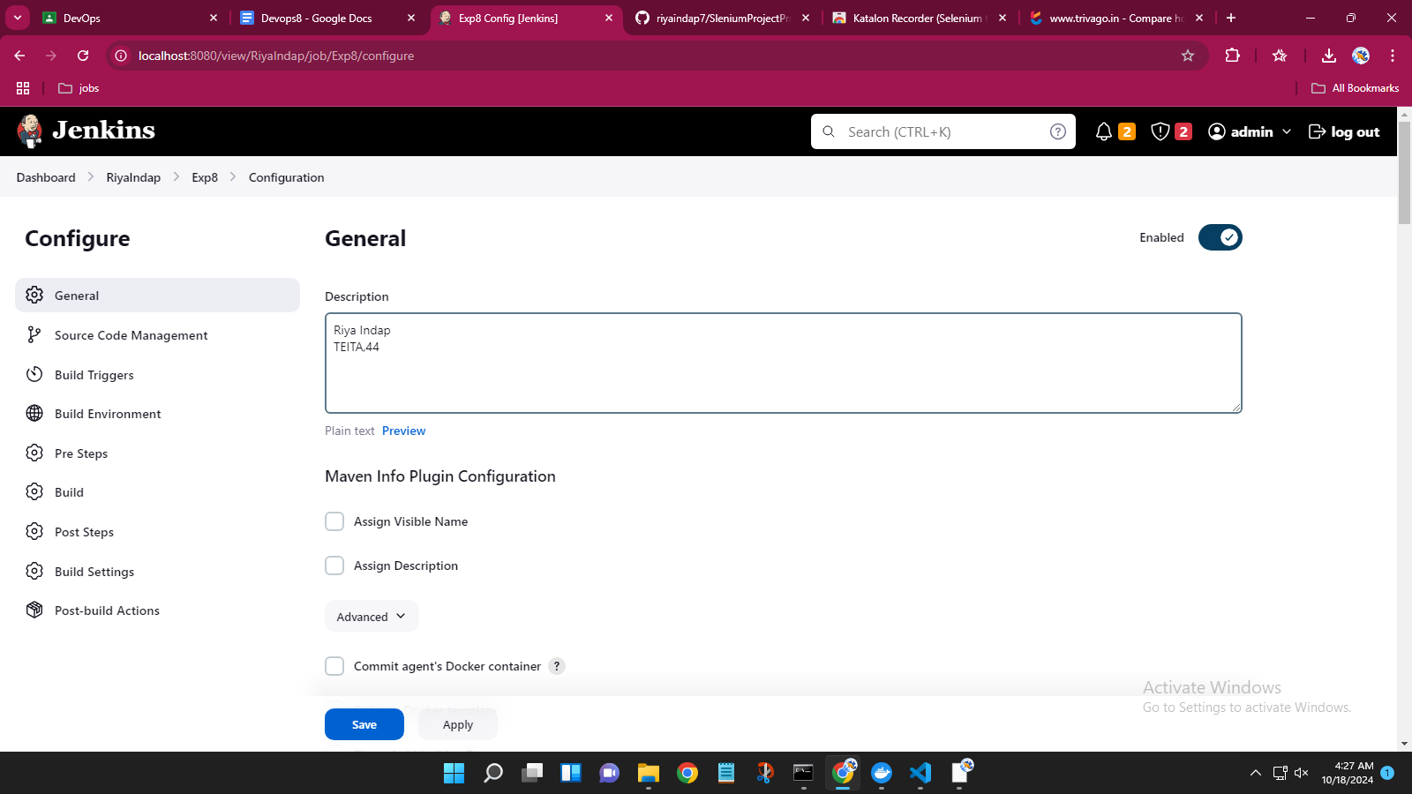

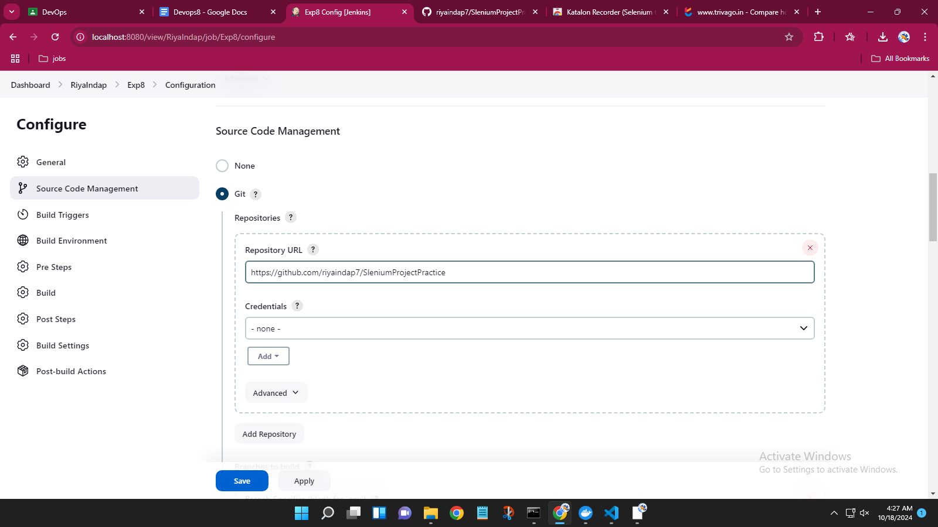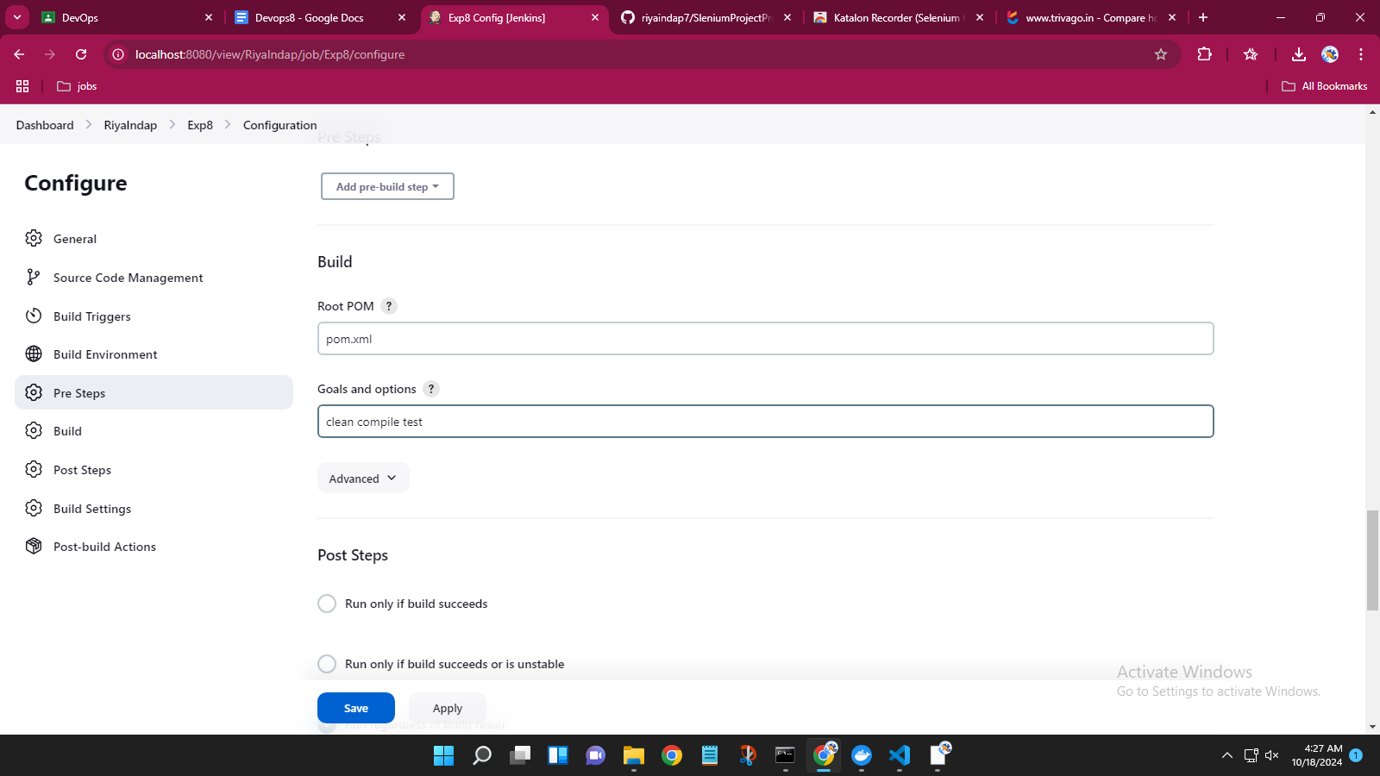

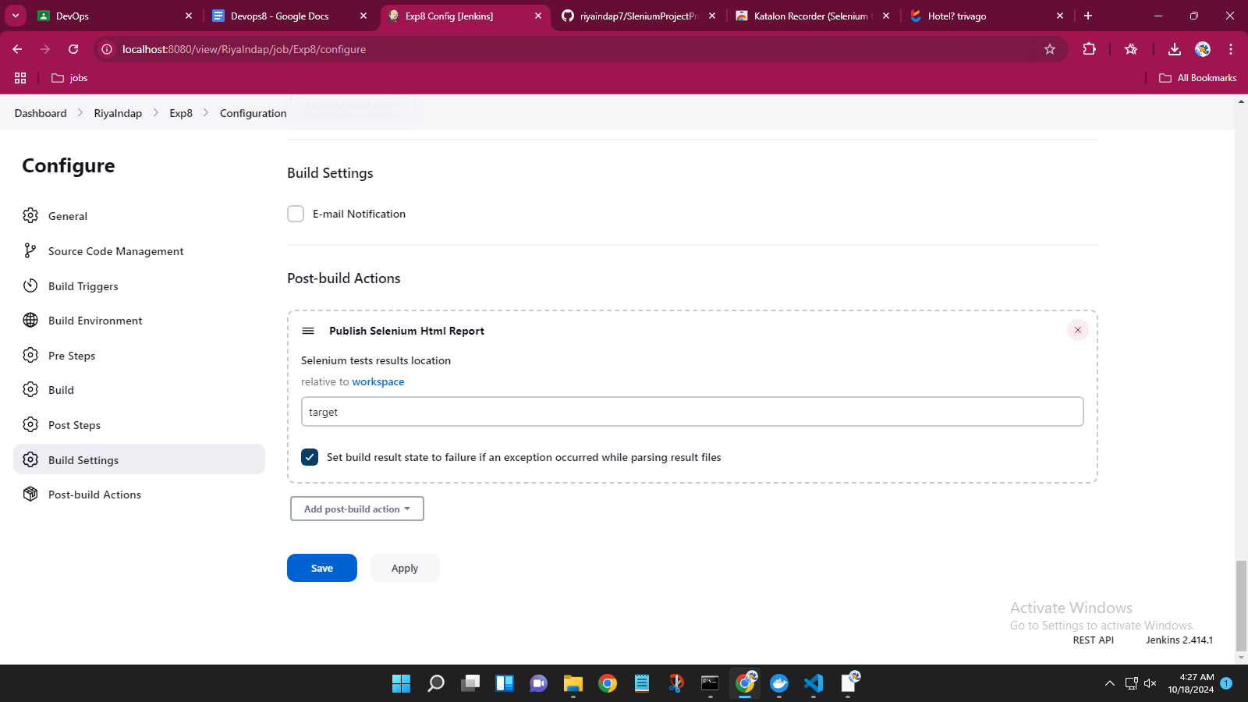

Test report of the grid created and configured.

